All statements are hyperlinked to original documents. >30 organizations say “SAFER than smoking.”

World Health Organization EURO Office: “There is conclusive evidence that: Completely substituting electronic nicotine and non-nicotine delivery systems for combustible tobacco cigarettes reduces users’ exposure to numerous toxicants and carcinogens present in combustible tobacco cigarettes.”

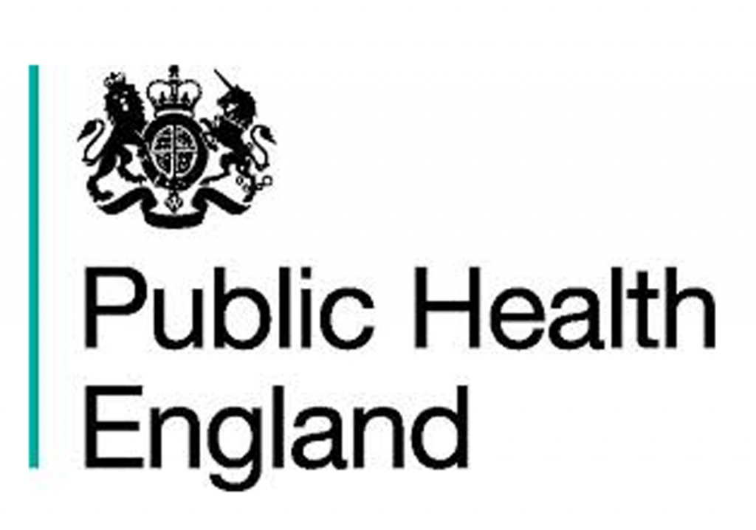
Public Health England: “Our new review reinforces the finding that vaping is a fraction of the risk of smoking, at least 95% less harmful, and of negligible risk to bystanders. Yet over half of smokers either falsely believe that vaping is as harmful as smoking or just don’t know.”

Royal College of Physicians: “Although it is not possible to precisely quantify the long-term health risks associated with e-cigarettes, the available data suggest that they are unlikely to exceed 5% of those associated with smoked tobacco products, and may well be substantially lower than this figure… E-cigarettes are effective in helping people to stop smoking.”

British Medical Association: “Significant numbers of smokers are using e-cigarettes (electronic cigarettes), with many reporting that they are helpful in quitting or cutting down cigarette use. There are clear potential benefits to their use in reducing the substantial harms associated with smoking, and a growing consensus that they are significantly less harmful than tobacco use.”

Cancer Research UK: “While the long-term health consequences of e-cigarette use are uncertain, the evidence so far suggests that e-cigarettes are far less harmful than smoking. ...There is also growing evidence to suggest that e-cigarettes can work successfully as an aid to cessation. …There is insufficient evidence to support a blanket indoor ban on e-cigarette use, either on the basis of renormalisation of smoking or harm to bystanders from second-hand vapour.”
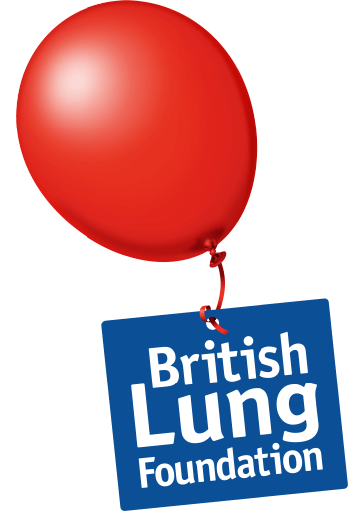
British Lung Foundation: “Experts have reviewed all the research done on e-cigarettes over the past few years, and found no significant risks for people using e-cigarettes. ...Swapping cigarettes for an e-cig can improve your symptoms of lung conditions like asthma and COPD.”

Royal College of General Practitioners: “The evidence so far shows that e-cigarettes have significantly reduced levels of key toxicants compared to cigarettes, with average levels of exposure falling well below the thresholds for concern.”

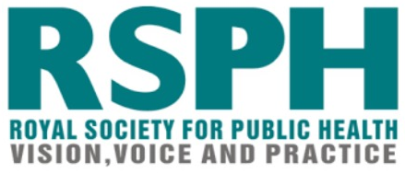
Royal Society for Public Health: “RSPH has welcomed a new comprehensive evidence review on e-cigarettes published by Public Health England (PHE). The report reflects an up-to-date evidence base that is increasingly pointing in the same direction: not only that vaping is at least 95% less harmful than smoking, but also that it is helping increasing numbers of smokers to quit.”

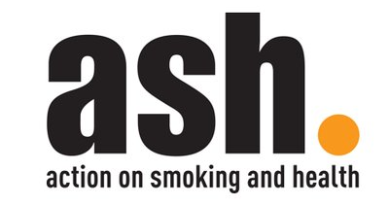
Action on Smoking and Health UK: “It has been estimated that e-cigarettes are 95% less harmful than ordinary cigarettes. There is negligible risk to others from second-hand e-cigarette vapour. ...The lifetime cancer risk of vaping has been assessed to be under 0.5% of the risk of smoking. [But] Public understanding of the relative harms of e-cigarettes [vs smoking cigarettes] have worsened over time and are less accurate today than they were in 2014.”

National Health Service Scotland consensus statement on e-cigarettes: “Smoking kills. Helping people to stop smoking completely is our priority. …There is now agreement based on the current evidence that vaping e-cigarettes is definitely less harmful than smoking tobacco.”
This statement was created and endorsed by: Action on Smoking & Health Scotland • Cancer Research UK • Chest Heart & Stroke Scotland • Chief Medical Officer for Scotland • NHS Ayrshire and Arran • NHS Greater Glasgow and Clyde • NHS Lothian • NHS Tayside • Roy Castle Lung Cancer Foundation • Royal College of General Practitioners • Royal College of Physicians of Edinburgh • Royal College of Physicians and Surgeons of Glasgow • Royal Environmental Health Institute of Scotland • Scottish Collaboration for Public Health Research and Policy • Scottish Consultants in Dental Health • Scottish Thoracic Society • UK Centre for Tobacco & Alcohol Studies • University of Edinburgh • University of Stirling

New Zealand Ministry of Health: “The regulatory controls in the Smoke-free Environments Act 1990 were designed primarily for tobacco products that are smoked. They are inadequate for vaping and smokeless tobacco products, which are less harmful to users. There is an opportunity, through better regulation (and public information), to support smokers to switch to significantly less harmful alternatives, substantially reducing the risks to their health and those around them.”

Cancer Society of New Zealand: “E-cigarettes and smokeless tobacco products are less harmful than tobacco smoking.”

Royal Australian & New Zealand College of Psychiatrists: “Research shows that 70% of people with schizophrenia and 61% of people with bipolar disorder smoke compared to 16% of those without mental illness. …E-cigarettes and vaporizers provide a safer way to deliver nicotine to those who are unable to stop smoking, thereby minimizing the harms associated with smoking tobacco and reducing some of the health disparities experienced by people with mental illness.”

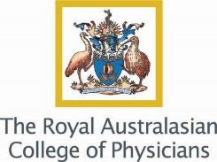
Royal Australian College of Physicians: “The RACP acknowledges that e-cigarettes may have a potential role in tobacco harm reduction and smoking cessation for smokers unable or unwilling to quit.”

German Federal Institute for Risk Assessment: “According to current knowledge, e-cigarettes are less harmful than conventional tobacco products when used as intended.”

French National Academy of Medicine: “It is established that the vaporette is less dangerous than the cigarette… It is therefore preferable for a smoker to vape. Since 2016, the High Authority for Health (HAS) considers it ‘as an aid to stop or reduce the consumption of tobacco by smokers.’ Santé Publique France indicates that at least 700,000 [French] smokers have quit using electronic cigarettes. ...Smokers who were about to switch to vaporizing instead of tobacco should not hesitate…” [Google Translate from original French]

French National Academy of Pharmacy: “The World Health Organization’s [anti-e-cigarette] position is incomprehensible. Tobacco is responsible for 73,000 deaths in France. The e-cigarette helps people quit smoking. Its components are obviously less harmful than tobacco.” [NOTE: This is a Tweet from the Académie Nationale de Pharmacie. Not an official statement.]

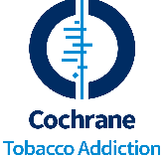
Cochrane Tobacco Addiction Group (Cochrane TAG): “No serious side effects were associated with [the use of e-cigarettes] (up to two years).”

US National Academies of Sciences, Engineering and Medicine: “While e-cigarettes are not without health risks, they are likely to be far less harmful than combustible tobacco cigarettes.”

US Food & Drug Administration: “Make no mistake. We see the possibility for ENDS products like e-cigarettes to provide a potentially less harmful alternative for currently addicted individual adult smokers who still want to get access to satisfying levels of nicotine without many of the harmful effects that come with the combustion of tobacco.”

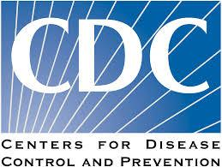
US Centers for Disease Control: “E-cigarettes have the potential to benefit adult smokers who are not pregnant if used as a complete substitute for regular cigarettes and other smoked tobacco products.”

American Cancer Society: “Based on currently available evidence, using current generation e-cigarettes is less harmful than smoking cigarettes.” [NOTE: This was the official statement from 2018-2019. As of November 2019, ACS no longer recommends e-cigarettes as a smoking cessation tool. Their stated reason for this change was “e-cigarette use by young people.” Yet their new statement still says, “former smokers now using e-cigarettes should not revert to smoking.” So, obviously, ecigs are LESS HARMFUL.]

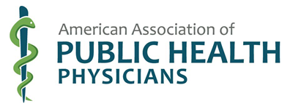
American Association of Public Health Physicians: “Smoke-free tobacco/nicotine products, as available on the American market, while not risk-free, carry substantially less risk of death and may be easier to quit than cigarettes. ...Smokers who have tried, but failed to quit using medical guidance and pharmaceutical products, and smokers unable or uninterested in quitting, should consider switching to a less hazardous smoke-free tobacco/nicotine product for as long as they feel the need. Such products include pharmaceutical Nicotine Replacement Therapy (NRT) products used, off-label, on a long term basis, electronic “e” cigarettes, dissolvables (sticks, strips and orbs), snus, other forms of moist snuff, and chewing tobacco.”

Government of Canada: “Vaping is less harmful than smoking. Completely replacing cigarette smoking with vaping will reduce your exposure to harmful chemicals. There are short-term general health improvements if you completely switch from smoking cigarettes to vaping products.”

